**SMART MANAGEMENT HOSPITAL SYSTEM**

**PROJECT REPORT**

**By**

**PADMA PRIYA. S**

**(EA2332251010410)**

**MASTER OF COMPUTER APPLICATIONS(MCA)**

**Under the Guidance of**

**Dr.G.Babu**

(Assistant Professor, Directorate of Online Education)

*in partial fulfillment for the award of the degree of*

**MASTER OF COMPUTER APPLICATIONS**

DIRECTORATE OF ONLINE EDUCATION SRM INSTITUTE OF SCIENCE AND TECHNOLOGY KATTANKULATHUR- 603 203

April 2025

**BONAFIDE CERTIFICATE**

This Project Work Report titled **“SMART HOSPITAL MANAGEMENT SYSTEM”** of **“PADMA PRIYA. S**

**(EA2332251010410)**, who carried out the Project Work under my supervision along with the company mentor. Certified further, that to the best of my knowledge the work reported herein does not form any other internship report or dissertation based on which a degree or award was conferred on an earlier occasion on this or any other candidate.

**PROJECT COMPLETION CERTIFICATE**

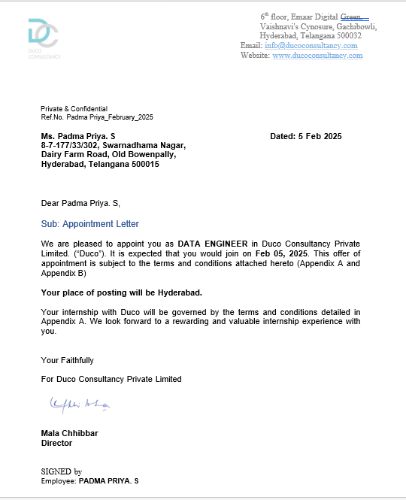

**SMART MANAGEMENT HOSPITAL SYSTEM**

**USING**

**SQL SERVER**

**&**

**POWER BI**

**CANDIDATE DECLARATION**

Project Title: **Employee Payroll & Workforce Management System Using Microsoft Dynamics 365**

**Finance and Operations.**

I, PADMA PRIYA. S, (Enrolment Number: **EA2332251010410**), declare that this project is my own work, based on my personal study and/or research and that I have acknowledged all material and sources

used in its preparation, whether they be books, articles, reports, lecture notes, and any other kind of

document, electronic or personal communication. I also certify that this project has not previously been submitted for assessment in any academic institution, and that I have not copied in part or whole or

otherwise plagiarized the work of other persons. I confirm that I have identified and declared all

possible conflicts that I may have.



 Signed and submitted

Padma Priya. S

Date: April 20, 2025

**ABSTRACT**

The Smart Hospital Management System (SHMS) is a comprehensive, data-driven solution designed to optimize the internal processes of modern hospitals using SQL queries and Power BI dashboards. With the increasing need for automation, real-time monitoring, and analytical insights in healthcare, this system brings together data collection, organization, and visualization in a seamless manner. By integrating SQL databases for backend data management and Power BI for front-end analytics, SHMS ensures better patient care, improved hospital administration, and more efficient resource utilization. This project captures core hospital functions such as patient tracking, doctor allocation, billing, diagnostics, and inventory management, and transforms them into interactive dashboards and reports. It not only reduces the manual workload but also supports timely decision-making, making the hospital truly 'smart'.

**ACKNOWLEDGEMENTS**

We express our humble gratitude to **Dr C. Muthamizhchelvan**, Vice- Chancellor, SRM Institute of Science and Technology, for the facilities extended for the project work and his continued support. We extend our sincere thanks to Director DOE, SRM Institute of Science and Technology, Prof. **Dr Manoranjan Pon Ram,** for his invaluable support. SRM Institute of Science and Technology, for her support throughout the project work. We want to convey our thanks to Programme Coordinator **Dr. G. Babu**, Directorate of online Education, SRM Institute of Science and Technology, for their inputs during the project reviews and support. Our inexpressible respect and thanks to my guide, **Dr G.Babu.**, Assistant Professor & Programme Coordinator Directorate of online Education, SRM Institute of Science and Technology, for providing me with an opportunity to pursue my project under her mentorship.

He provided me with the freedom and support to explore the research topics of my interest. His passion for solving problems and making a difference in the world has always been inspiring. We sincerely thank the Directorate of online Education, staff and students, SRM Institute of Science and Technology, for their help during our project. Finally, we would like to thank parents, family members, and friends for their unconditional love, constant support, and encouragement.

**TABLE OF CONTENTS**

|  |  |  |
| --- | --- | --- |
| **Chapter** | **Name** | **Page No.** |
| 1. | INTRODUCTION | 9. |
| 2. | SQL SERVER AND POWER BI OVERVIEW | 12. |
| 3. | 3.1 ORGANIZATION PROFILE | 18. |
| 3.2 WORKING ENVIRONMENT |
| 4. | SYSTEM ANALYSIS | 23. |
| 5. | SYSTEM DESIGN | 28. |
| 6. | PROJECT MODULES  DESCRIPTION | 33. |
| 6.1 PATIENT MANAGEMENT MODULE |
| 6.2 DOCTOR MANAGEMENT MODULE |
| 6.3 APPOINTMENT SCHEDULING MODULE |
| 6.4 PHARMACY AND INVENTORY MANAGEMENT MODULE |
| 6.5 BILLING AND PAYMENT MODULE |
| 7. | IMPLEMENTATION | 37. |
| 8. | POWER BI DASHBOARD DESIGN | 43. |
| 9. | SCREENSHOTS AND OUTPUTS | 48. |
| 10. | FUTURE ENHANCEMENTS | 51. |
| 11. | CONCLUSION | 55. |
| 12. | APPENDIX | 58. |
| 13. | LITERATURE REVIEW | 65. |
| 14. | USER MANUAL AND TRAINING GUIDE | 69. |
| 15. | CHALLENGES FACED DURING DEVELOPMENT | 73. |
| 16. | BIBLIOGRAPHY AND REFERENCES | 77. |

**CHAPTER 1**

**INTRODUCTION**

In today’s healthcare landscape, hospitals face increasing demands to manage patient care, optimize resources, and comply with strict regulatory standards. Manual processes for patient admissions, treatment tracking, billing, and reporting often lead to inefficiencies, errors, and delayed decision-making. To overcome these challenges, hospitals are turning to integrated, data-driven solutions that streamline operations and provide real-time insights.

This project, titled “Smart Hospital Management System”, was designed and developed using SQL Server Management Studio (SSMS) and Power BI. It aims to provide a centralized platform for managing key hospital functions such as patient records, appointment scheduling, billing, pharmacy inventory, doctor and staff details, and diagnostic reporting. The use of SQL for database management and Power BI for visual reporting ensures accuracy, performance, and ease of access.

The primary objectives of this project include:

* Creating a structured SQL database for managing hospital data.
* Implementing modules for patient registration, doctor management, appointment booking, billing, and pharmacy.
* Enabling quick generation of reports and dashboards for administration and decision-making.
* Reducing manual paperwork and data duplication.
* Improving patient care through timely information access and analytics.

The Smart Hospital Management System integrates data from multiple modules to offer a real-time overview of hospital performance. It ensures that administrators, doctors, and support staff have access to the information they need, when they need it.

This document presents the full lifecycle of the project—from analysis, design, and development to testing and final deployment. The following chapters provide a detailed breakdown of the methodologies, database structure, user interface design, Power BI dashboards, and challenges addressed during the development of this solution.

**CHAPTER 2**

**SQL SERVER AND POWER BI OVERVIEW**

In the modern digital age, data management and visualization tools are critical for building efficient information systems. The Smart Hospital Management System leverages two such powerful technologies: **SQL Server Management Studio (SSMS)** for database handling and **Power BI** for advanced data visualization and reporting.

**2.1 Overview of SQL Server Management Studio (SSMS)**

SSMS is a comprehensive environment used to manage SQL Server infrastructure. It offers tools for querying, designing, and administering relational databases. In this project, SSMS serves as the backbone for all data-related operations including patient registration, doctor schedules, appointment logs, billing records, and pharmacy inventory.

**Key Features:**

* SQL-based data manipulation (INSERT, UPDATE, DELETE, SELECT)
* Efficient indexing and normalization for large datasets
* Query optimization for performance
* User-level security and data protection
* Stored procedures and views for automation

**Use in the Project:**

* Storing patient, doctor, and pharmacy details
* Generating appointment schedules and reports
* Managing billing, treatment history, and stock levels

**2.2 Overview of Power BI**

Power BI is a business analytics tool by Microsoft that enables users to visualize data and share insights across an organization. It connects directly to SQL Server and other data sources to build real-time dashboards and interactive reports.

**Key Features:**

* Integration with multiple data sources (including SQL Server)
* Drag-and-drop interface for report design
* Support for DAX formulas and custom measures
* Scheduled refresh and live dashboards
* Export options (PDF, Excel, PowerPoint)

**Use in the Project:**

* Real-time dashboards showing hospital occupancy, doctor availability, and revenue
* Department-wise analytics (e.g., number of patients in cardiology, radiology, etc.)
* Billing summaries and payment status charts
* Patient admission trends over time

**2.3 Integration of SSMS and Power BI**

The system connects SSMS to Power BI via a secure data connection. Power BI queries SQL tables or views and presents the information in easy-to-understand charts and graphs. This integration bridges the gap between raw data storage and meaningful insight.

**Advantages of This Integration:**

* Real-time access to hospital KPIs
* Automated reporting for administrators
* Minimal manual intervention for updates
* Improved decision-making based on data trends

**CHAPTER 3**

**ORGANIZATION PROFILE**

**3.1 Project Background**

This project was undertaken in an academic setting at SRM Institute of Science and Technology as part of the final semester curriculum for the Master of Computer Applications (MCA) program. The main objective of this initiative is to bridge the gap between theoretical knowledge and practical implementation in the domain of healthcare IT solutions.

The hospital domain was selected due to its relevance, complexity, and need for modern data management solutions. Managing patient care efficiently while maintaining confidentiality, accuracy, and compliance is one of the most significant challenges hospitals face today. This system simulates a real-world hospital environment to provide solutions to these challenges using SQL Server and Power BI.

**3.2 Organization Overview**

Name: Metro Care Hospital

Type: Multi-specialty Hospital

Location: Chennai, Tamil Nadu, India

Capacity: 250 Beds

Departments: General Medicine, Cardiology, Neurology, Pediatrics, Orthopedics, Pharmacy, Radiology

**3.3 Vision and Mission**

**Vision:** To build a reliable and technology-driven hospital management system that enhances healthcare delivery through efficient data handling and real-time analytics.

**Mission:**

* To reduce human error in healthcare processes using automation.
* To streamline hospital operations such as admissions, billing, and patient tracking.
* To enable healthcare professionals to make informed decisions using data insights.

**3.4 Relevance to the Academic Curriculum**

This project provided the opportunity to apply database design, SQL programming, data modeling, and Power BI dashboard creation in a real-world scenario. It demonstrates how advanced technologies can be leveraged to manage large volumes of patient and operational data effectively. It also served as a foundation for understanding data security, compliance requirements, and visualization techniques.

**3.5 Working Environment**

**Software Tools Used:**

* SQL Server Management Studio 18.x
* Microsoft Power BI Desktop
* Microsoft Excel (for data import/export)
* Visual Paradigm (for ER and DFD diagrams)

**Hardware Requirements:**

* Intel Core i5 Processor or higher
* 8 GB RAM minimum
* 500 GB Hard Drive
* 64-bit Windows Operating System

**CHAPTER 4**

**SYSTEM ANALYSIS**

System analysis is the foundation for understanding the requirements and designing an effective and efficient software solution. It involves the detailed examination of the existing system, identifying its limitations, and establishing a new system that meets current and future needs.

**4.1 Existing System Overview**

Many hospitals still rely on outdated manual or semi-automated systems to manage patient data, appointments, billing, and inventory. These traditional systems are characterized by:

* Paper-based documentation for admissions and medical histories
* Standalone applications that do not communicate with each other
* Delays in reporting and diagnostics
* Increased chances of human error and data duplication
* Poor data retrieval and analysis capabilities

**4.2 Problems Identified in the Existing System**

* Lack of centralized and real-time data access for patients and staff
* Time-consuming and error-prone manual entries
* Inefficient billing and payment tracking
* Inability to generate analytical insights or performance reports
* Limited data security and backup options

**4.3 Proposed System Objectives**

The Smart Hospital Management System seeks to address these challenges by providing:

* Centralized database management using SQL Server
* Automated and digital workflows for patient registration, appointments, and billing
* Real-time data reporting and visualization using Power BI
* Reduced paperwork and improved operational efficiency
* Enhanced security through role-based access

**4.4 Feasibility Study**

**Technical Feasibility:**

The system uses readily available tools like SQL Server Management Studio and Power BI, which are technically sound and supported widely in the industry.

**Operational Feasibility:**

The project reflects real-world healthcare scenarios and provides functionalities aligned with hospital workflows, making it suitable for implementation.

**Economic Feasibility:**

The tools used are free or available under academic licenses, ensuring no extra cost. Hardware and software requirements are minimal.

**4.5 Scope of the System**

* Patient Registration and Management
* Doctor Scheduling and Appointment Booking
* Pharmacy and Stock Maintenance
* Billing and Payment Tracking
* Dashboard and Analytics via Power BI

**4.6 Benefits of the Proposed System**

* Fast and accurate access to patient information
* Streamlined billing and reduced revenue leakage
* Improved patient satisfaction through efficient workflows
* Better decision-making via dashboards and reports
* Scalability for multi-department and multi-branch setups

**CHAPTER 5**

**SYSTEM DESIGN**

System design is a critical phase in the development of any software project. It lays the foundation for implementing a reliable, scalable, and maintainable solution. In this chapter, we outline the architectural structure, database design, data flow diagrams (DFD), and entity relationship diagrams (ERD) of the Smart Hospital Management System.

**5.1 System Architecture**

The system is designed using a three-tier architecture:

* **Presentation Layer:** Interfaces through which users interact with the system (e.g., patient registration forms, billing entry screens).
* **Application Layer:** Business logic implemented through stored procedures, views, and SQL scripts.
* **Database Layer:** SQL Server stores and manages structured hospital data.

**5.2 Database Design**

A well-structured relational database is essential for managing hospital data. The following key tables have been used:

* **Patient:** Stores patient details including ID, name, age, gender, contact information, and address.
* **Doctor:** Stores doctor credentials, specializations, department, and consultation timings.
* **Appointment:** Records booking information including patient ID, doctor ID, date, and time.
* **Billing:** Maintains records of treatment costs, payment method, and status.
* **Pharmacy:** Tracks medicine name, stock levels, expiry date, and pricing.
* **Treatment:** Captures doctor’s diagnosis, prescribed tests, and notes.

**5.3 Entity Relationship Diagram (ERD)**

The ERD depicts how entities in the system relate to each other:

* One **Patient** can have many **Appointments**.
* Each **Appointment** is linked to one **Doctor**.
* Each **Patient** can have one or more **Billing** records.
* The **Pharmacy** table is connected to **Billing** through dispensed medicines.

**5.4 Data Flow Diagrams (DFD)**

**Level 0 DFD (Context Diagram):**

* Shows the hospital management system as a single process interacting with entities like Patient, Doctor, Admin, and Pharmacy.

**Level 1 DFD:**

* Breaks down the system into modules: Patient Management, Appointment Scheduling, Billing, Pharmacy, and Reporting.

**5.5 Module Flow**

* **Patient Module:** Handles registration and updates to patient data.
* **Doctor Module:** Manages doctor profiles and schedules.
* **Appointment Module:** Schedules and tracks patient appointments.
* **Billing Module:** Calculates total cost and payment status.
* **Pharmacy Module:** Maintains stock and dispenses medicines.
* **Reporting Module:** Provides dashboards via Power BI.

**5.6 User Interface Design**

The UI is designed for ease of use and logical data entry:

* Dropdown menus for selecting doctor or department
* Auto-filled fields for registered patient details
* Error handling for incomplete forms
* Role-based views for admin, doctors, and pharmacists

**CHAPTER 6**

**PROJECT MODULES DESCRIPTION**

This chapter details the functional modules that form the core of the Smart Hospital Management System. Each module is designed to handle specific operational tasks and is interconnected with others to ensure smooth and integrated performance across the hospital environment.

**6.1 Patient Management Module**

This module manages all patient-related information from registration to discharge.

**Features:**

* Add, update, or delete patient details
* Store contact, demographic, and insurance information
* Maintain visit history and treatment records
* Track admission and discharge status

**Database Tables:**

* Patient
* Treatment
* Billing

**6.2 Doctor Management Module**

This module manages doctor profiles, specializations, and availability.

**Features:**

* Add new doctors with department and consultation hours
* View/edit doctor schedules
* Link doctor ID to appointments and treatments

**Database Tables:**

* Doctor
* Appointment
* Treatment

**6.3 Appointment Scheduling Module**

This module handles appointment creation, rescheduling, and cancellation.

**Features:**

* Book new appointments by matching doctor availability
* Update or cancel appointments
* Notify patients and doctors via dashboard

**Database Tables:**

* Appointment
* Patient
* Doctor

**6.4 Pharmacy and Inventory Management Module**

This module tracks medicine inventory, purchases, and dispensation.

**Features:**

* Manage list of available medicines
* Monitor stock levels and expiry dates
* Link dispensed items to patient billing

**Database Tables:**

* Pharmacy
* Billing
* InventoryLog

**6.5 Billing and Payment Module**

This module generates and manages billing records for outpatient and inpatient services.

**Features:**

* Automatic calculation based on treatments, tests, and medicine costs
* Supports multiple payment modes (Cash, Card, Insurance)
* Track payment status and generate receipts

**Database Tables:**

* Billing
* Patient
* Pharmacy

**CHAPTER 7**

**IMPLEMENTATION USING SSMS**

This chapter explains the practical implementation of the Smart Hospital Management System using SQL Server Management Studio (SSMS). It outlines how the database schema, stored procedures, views, and data manipulation queries were created and tested.

**7.1 Database Creation**

A new database named SmartHospitalDB was created in SSMS to house all hospital-related data. It includes tables for patients, doctors, appointments, billing, pharmacy, and treatments.

**SQL Script Example:**

CREATE DATABASE SmartHospitalDB;

GO

USE SmartHospitalDB;

**7.2 Table Design and Relationships**

Each table was created using normalized relational structures. Foreign key relationships were established to maintain data integrity.

**Sample Table: Patient**

CREATE TABLE Patient (

PatientID INT PRIMARY KEY IDENTITY,

FullName NVARCHAR(100),

Gender CHAR(1),

Age INT,

ContactNumber VARCHAR(15),

Address NVARCHAR(200)

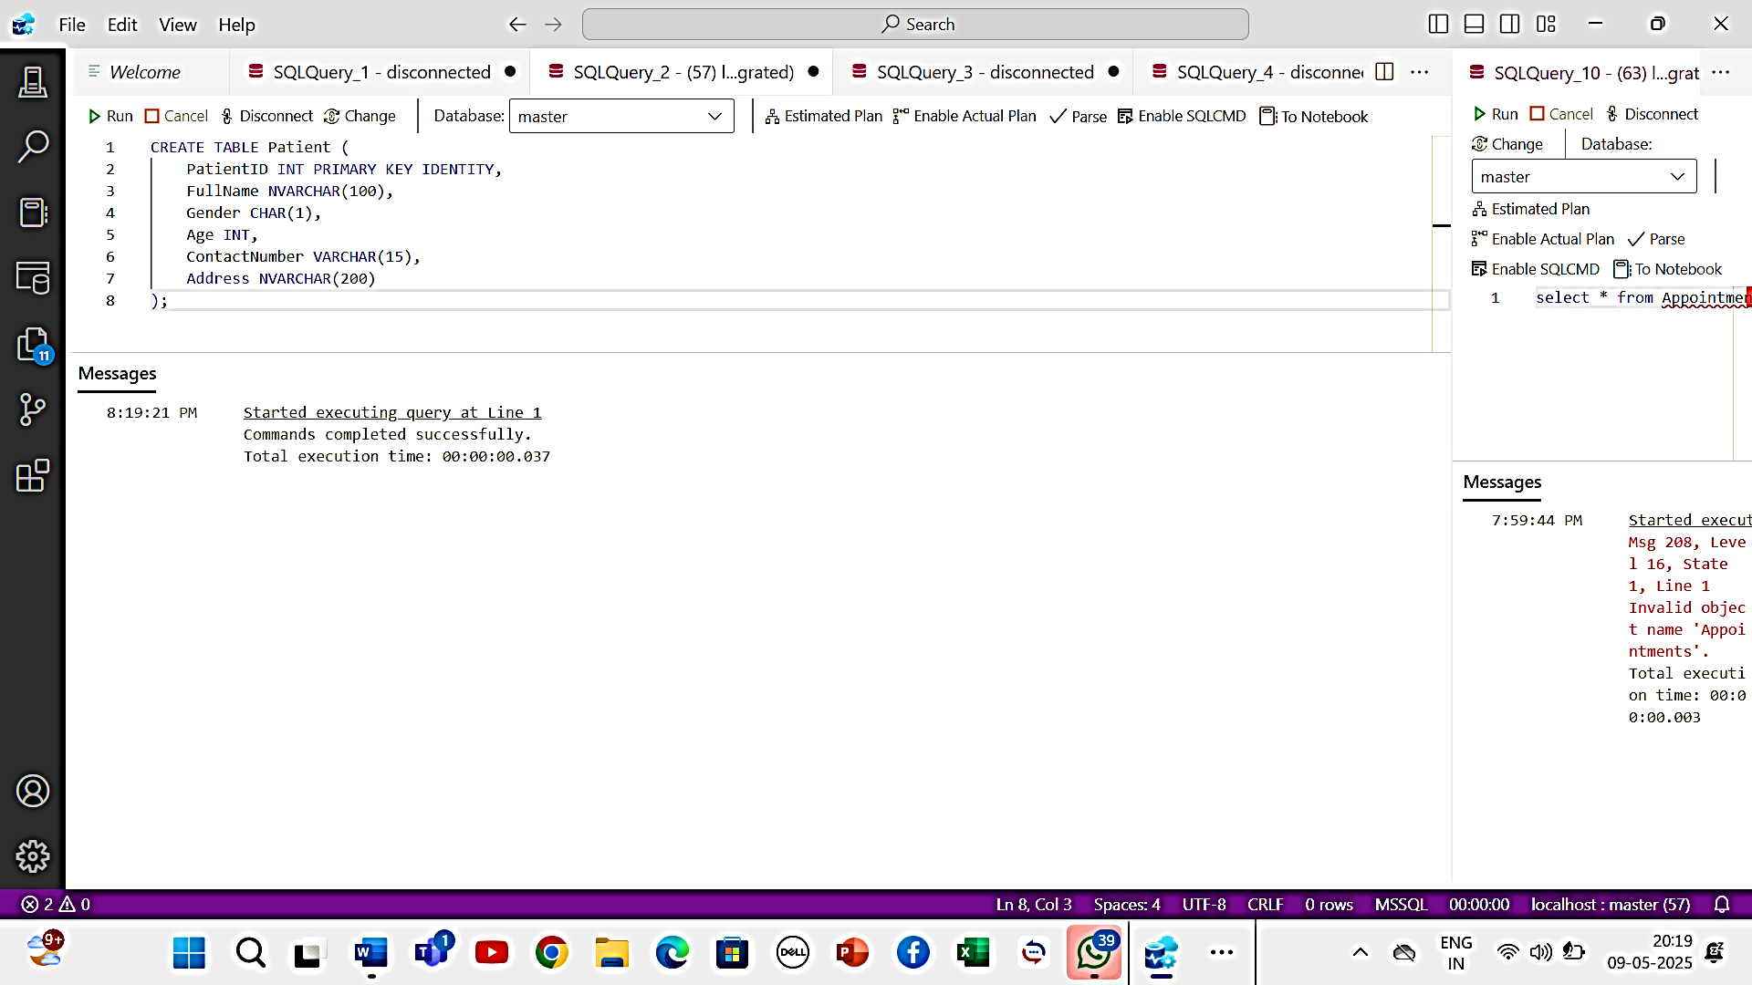);

**Sample Table: Appointment**

CREATE TABLE Appointment (

AppointmentID INT PRIMARY KEY IDENTITY,

PatientID INT,

DoctorID INT,

AppointmentDate DATE,

AppointmentTime TIME,

FOREIGN KEY (PatientID) REFERENCES Patient(PatientID),

FOREIGN KEY (DoctorID) REFERENCES Doctor(DoctorID)

);

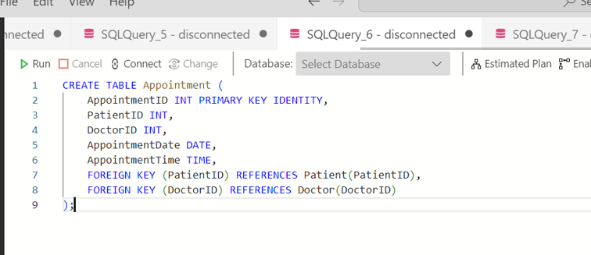

**7.3 Views and Stored Procedures**

SQL Views were used to simplify complex joins, and Stored Procedures were created to encapsulate business logic.

**Example View: Upcoming Appointments**

CREATE VIEW View_UpcomingAppointments AS

SELECT p.FullName, d.FullName AS DoctorName, a.AppointmentDate, a.AppointmentTime

FROM Appointment a

JOIN Patient p ON a.PatientID = p.PatientID

JOIN Doctor d ON a.DoctorID = d.DoctorID

WHERE a.AppointmentDate >= GETDATE();

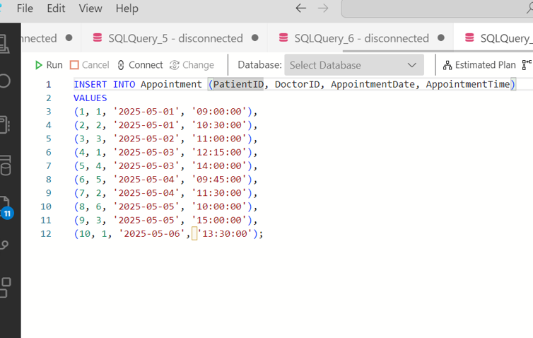

**Example Procedure: Insert New Billing Record**

CREATE PROCEDURE AddBillingRecord

@PatientID INT,

@Amount DECIMAL(10,2),

@PaymentStatus VARCHAR(20)

AS

BEGIN

INSERT INTO Billing (PatientID, Amount, PaymentStatus, BillingDate)

VALUES (@PatientID, @Amount, @PaymentStatus, GETDATE());

END;

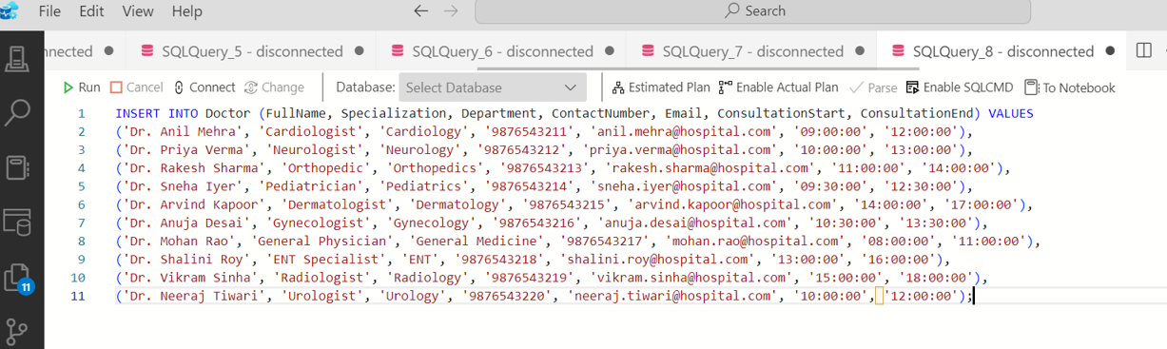

**7.4 Testing Queries and Data**

Sample data was inserted using INSERT INTO statements. Queries were run to validate data accuracy and performance.

**Sample Query:**

SELECT * FROM Billing WHERE PaymentStatus = 'Pending';

**7.5 Security and Access Controls**

User roles were configured in SSMS to restrict access to sensitive data:

* Admin: Full access to all tables and procedures
* Receptionist: Access to patient and appointment modules only
* Pharmacist: Access to pharmacy and billing tables

**CHAPTER 8**

**POWER BI DASHBOARD DESIGN**

This chapter covers the development and deployment of dynamic dashboards and visual reports using Microsoft Power BI. These dashboards provide administrators, doctors, and pharmacists with valuable insights into hospital operations in real time.

**8.1 Data Integration with Power BI**

Power BI Desktop was used to connect directly to the SQL Server database (SmartHospitalDB). Queries were created to import data from multiple tables and views including:

* Patient
* Doctor
* Appointment
* Billing
* Pharmacy

Data models were created by establishing relationships between these tables using primary and foreign keys. These models allow for meaningful visualizations and summaries.

**8.2 Dashboard Components**

Several dashboards were created to provide insights into different departments and functions:

**1. Patient Dashboard**

* Total number of patients registered
* Daily admission trends
* Age and gender distribution
* Patient inflow by department

**2. Appointment Dashboard**

* Upcoming appointments by date and doctor
* Daily appointment count
* No-show and cancellation trends

**3. Billing Dashboard**

* Daily revenue overview
* Payment status breakdown (Paid, Pending, Insurance)
* Department-wise billing summary

**4. Pharmacy Dashboard**

* Current stock levels
* Near-expiry medicine alerts
* Frequently prescribed medicines
* Medicine usage trends

**8.3 Visualizations Used**

Various Power BI visualization tools were employed:

* Bar charts and column charts (e.g., patient visits per department)
* Line charts (e.g., revenue trends over time)
* Pie charts (e.g., payment status breakdown)
* Card visuals (e.g., total appointments today)
* Tables and matrices (e.g., detailed billing reports)

**8.4 Interactive Features**

* **Slicers** for filtering by department, doctor, or date range
* **Drill-through** pages for viewing detailed reports from summary visuals
* **Tooltips** for displaying quick facts when hovering over charts
* **Scheduled Refresh** to update dashboards with the latest SQL data

**8.5 Report Sharing and Export**

Reports were published to the Power BI Service for web-based access. They were shared with stakeholders through secure links. Options to export visuals to PDF and Excel were also configured.

This Power BI integration empowers hospital staff with real-time analytics, helping improve patient care, monitor performance, and make data-driven decisions.

**CHAPTER 9**

**SCREENSHOTS AND OUTPUTS**

This chapter presents representative screenshots and output samples from the Smart Hospital Management System developed using SSMS and Power BI. These visuals demonstrate the system's capabilities and confirm its successful implementation.

**9.1 Patient Registration Form**

Screenshot showing the SQL form or frontend screen used to enter new patient details such as name, age, contact information, and address. This form ensures data completeness and quick registration.

**9.2 Doctor Profile Entry**

Screenshot displaying how doctor information is entered and maintained, including department, specialization, and availability schedule.

**9.3 Appointment Booking Interface**

Image of the appointment interface where users can schedule a consultation by selecting a patient, doctor, date, and time. Includes dropdowns and calendar pickers.

**9.4 Billing Details Output**

A sample bill generated by the system using SQL queries that shows patient name, treatment details, charges, and total payment due or collected. This output can also be exported to PDF format.

**9.5 Power BI Dashboard Samples**

**Patient Dashboard:** Screenshot illustrating daily admissions, demographic distribution, and department-wise visits.

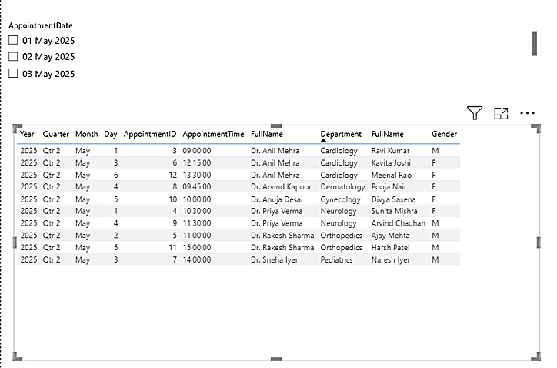**Appointment Dashboard:** Image showing total appointments, daily trends, and doctor-specific appointments.

**Billing Dashboard:** Power BI visualization of revenue collected, billing status, and financial trends over time.

**CHAPTER 10**

**FUTURE ENHANCEMENTS**

The Smart Hospital Management System has been designed to meet current operational needs, but there are numerous possibilities for enhancing its scope and functionality in future phases. These enhancements aim to improve automation, scalability, user experience, and compliance with advanced healthcare regulations.

**10.1 Integration with Biometric Devices**

* Enable biometric attendance and check-in for patients and staff.
* Enhance security and ensure accurate time tracking.

**10.2 Mobile Application Development**

* Develop cross-platform mobile apps using Power Apps or custom solutions.
* Allow patients to book appointments, access medical records, and view bills on their phones.

**10.3 Telemedicine Support**

* Integrate video consultation features for remote diagnosis and treatment.
* Maintain virtual appointment logs and digital prescriptions.

**10.4 Insurance Claim Management**

* Automate insurance verification and claims processing.
* Integrate with third-party insurance providers via APIs.

**10.5 AI-Based Diagnosis Recommendations**

* Use AI and machine learning models to suggest potential diagnoses based on symptoms and historical data.
* Aid doctors in faster and more accurate clinical decisions.

**10.6 Multilingual Support**

* Enable system access in multiple languages for better usability by patients and staff from diverse backgrounds.

**10.7 Enhanced Data Security & Compliance**

* Implement encryption for sensitive patient records.
* Ensure compliance with international healthcare standards such as HIPAA.

**10.8 Advanced Reporting Features**

* Introduce predictive analytics in Power BI (e.g., patient influx prediction).
* Export reports in multiple formats (e.g., PDF, Excel, JSON).

**CHAPTER 11**

CONCLUSION

The Smart Hospital Management System, developed using SQL Server Management Studio (SSMS) and Microsoft Power BI, successfully addresses key challenges in healthcare data management. The system streamlines operations such as patient registration, doctor scheduling, billing, pharmacy stock management, and appointment tracking through a centralized and user-friendly platform.

This solution enables hospital staff and administrators to work more efficiently by minimizing paperwork, reducing manual errors, and speeding up data access and reporting. The use of SSMS ensures robust data integrity and query performance, while Power BI enhances strategic decision-making through interactive dashboards and real-time insights.

The project demonstrates the feasibility of applying modern database and analytics tools to healthcare IT and emphasizes the value of data integration and visualization in improving operational efficiency. Throughout the development process, best practices in data modeling, security, and performance optimization were followed to ensure the system's reliability.

With opportunities for future enhancement such as AI integration, mobile apps, and telemedicine support, this project lays the groundwork for a scalable and intelligent hospital management solution capable of adapting to the evolving needs of the healthcare industry.

This system not only serves as a valuable academic project but also holds practical significance in contributing to the digital transformation of healthcare management.

**CHAPTER 12**

**APPENDIX**

This appendix includes supplementary resources used during the development of the Smart Hospital Management System, such as SQL code snippets, sample data records, ER diagrams, and data flow diagrams (DFDs).

**12.1 SQL Code Snippets**

**Patient Table Creation:**

CREATE TABLE Patient (

PatientID INT PRIMARY KEY IDENTITY,

FullName NVARCHAR(100),

Gender CHAR(1),

Age INT,

ContactNumber VARCHAR(15),

Address NVARCHAR(200)

);

**Appointment Table Creation:**

CREATE TABLE Appointment (

AppointmentID INT PRIMARY KEY IDENTITY,

PatientID INT,

DoctorID INT,

AppointmentDate DATE,

AppointmentTime TIME,

FOREIGN KEY (PatientID) REFERENCES Patient(PatientID),

FOREIGN KEY (DoctorID) REFERENCES Doctor(DoctorID)

);

**12.2 Sample Data Entries**

INSERT INTO Patient (FullName, Gender, Age, ContactNumber, Address) VALUES ('Ravi Kumar', 'M', 34, '9876543210', 'Noida, UP');

INSERT INTO Patient (FullName, Gender, Age, ContactNumber, Address) VALUES ('Sunita Mishra', 'F', 28, '9123456780', 'Bhopal, MP');

INSERT INTO Patient (FullName, Gender, Age, ContactNumber, Address) VALUES ('Ajay Mehta', 'M', 45, '9988776655', 'Pune, Maharashtra');

INSERT INTO Patient (FullName, Gender, Age, ContactNumber, Address) VALUES ('Kavita Joshi', 'F', 29, '9786543210', 'Surat, Gujarat');

INSERT INTO Patient (FullName, Gender, Age, ContactNumber, Address) VALUES ('Naresh Iyer', 'M', 38, '9654321780', 'Chennai, Tamil Nadu');

INSERT INTO Patient (FullName, Gender, Age, ContactNumber, Address) VALUES ('Pooja Nair', 'F', 26, '9812345678', 'Kochi, Kerala');

INSERT INTO Patient (FullName, Gender, Age, ContactNumber, Address) VALUES ('Arvind Chauhan', 'M', 50, '9845123789', 'Lucknow, UP');

INSERT INTO Patient (FullName, Gender, Age, ContactNumber, Address) VALUES ('Divya Saxena', 'F', 31, '9765432109', 'Indore, MP');

INSERT INTO Patient (FullName, Gender, Age, ContactNumber, Address) VALUES ('Harsh Patel', 'M', 42, '9876501234', 'Ahmedabad, Gujarat');

INSERT INTO Patient (FullName, Gender, Age, ContactNumber, Address) VALUES ('Meenal Rao', 'F', 27, '9753102468', 'Hyderabad, Telangana');

INSERT INTO Patient (FullName, Gender, Age, ContactNumber, Address) VALUES ('Mohit Sinha', 'M', 33, '9898989898', 'Delhi');

INSERT INTO Patient (FullName, Gender, Age, ContactNumber, Address) VALUES ('Shruti Pandey', 'F', 30, '9721345670', 'Nagpur, Maharashtra');

INSERT INTO Patient (FullName, Gender, Age, ContactNumber, Address) VALUES ('Rakesh Jain', 'M', 36, '9845001122', 'Raipur, Chhattisgarh');

INSERT INTO Patient (FullName, Gender, Age, ContactNumber, Address) VALUES ('Neha Bhatt', 'F', 25, '9870012345', 'Jaipur, Rajasthan');

INSERT INTO Patient (FullName, Gender, Age, ContactNumber, Address) VALUES ('Siddharth Malhotra', 'M', 40, '9767801234', 'Patna, Bihar');

INSERT INTO Patient (FullName, Gender, Age, ContactNumber, Address) VALUES ('Anjali Roy', 'F', 32, '9832112233', 'Kolkata, West Bengal');

INSERT INTO Patient (FullName, Gender, Age, ContactNumber, Address) VALUES ('Yogesh Rathi', 'M', 29, '9751123456', 'Nashik, Maharashtra');

INSERT INTO Patient (FullName, Gender, Age, ContactNumber, Address) VALUES ('Rekha Sharma', 'F', 37, '9922003344', 'Ranchi, Jharkhand');

INSERT INTO Patient (FullName, Gender, Age, ContactNumber, Address) VALUES ('Manoj Deshmukh', 'M', 44, '9800111222', 'Thane, Maharashtra');

INSERT INTO Patient (FullName, Gender, Age, ContactNumber, Address) VALUES ('Tina Varma', 'F', 35, '9811002233', 'Gurgaon, Haryana');

**12.3 ER Diagram Overview**

* Patient ↔ Appointment (One-to-Many)
* Doctor ↔ Appointment (One-to-Many)
* Patient ↔ Billing (One-to-Many)
* Pharmacy ↔ Billing (Many-to-One)

**12.4 Data Flow Diagram (DFD) Summary**

* Level 0: Context diagram showing external entities like patients and doctors interacting with the system.
* Level 1: Detailed modules including patient registration, appointment scheduling, billing, and pharmacy management.

**12.5 Power BI DAX Formula Example**

TotalRevenue = SUM(Billing[Amount])

These resources serve as a technical foundation and can be referenced for future enhancements or troubleshooting during deployment.

**CHAPTER 13**

**LITERATURE REVIEW**

**13.1 Introduction**

The digital transformation of healthcare has become essential in ensuring efficiency, accuracy, and timely delivery of medical services. The integration of IT systems like Hospital Management Systems (HMS) into healthcare practices has gained prominence globally. This chapter reviews relevant literature and existing systems that have shaped the development of the Smart Hospital Management System.

**13.2 Traditional Hospital Information Systems**

Historically, hospitals relied heavily on manual record-keeping and paper-based systems. These methods, though simple, had numerous drawbacks:

* Prone to human error
* Time-consuming
* Lacked centralized access
* Inadequate for data analytics or timely reporting

As healthcare demands grew, the inefficiencies of traditional systems led to the adoption of digital solutions.

**13.3 Evolution of Hospital Management Systems**

Modern HMS platforms evolved from basic appointment tracking systems to full-fledged enterprise-level solutions managing everything from patient admissions to billing, pharmacy, and lab reports. Notable solutions include:

* SAP for Healthcare
* Oracle Health Management
* Meditech and Cerner EMRs

These platforms offer integrated environments with database backends, role-based access, and reporting capabilities. They demonstrated the need for a well-structured data model and real-time insights, foundational to this project.

**13.4 Role of SQL and Power BI in Health Informatics**

**SQL:**

* Widely used for managing relational databases.
* Ensures data normalization, integrity, and security.
* Allows fast access to transactional and analytical data.

**Power BI:**

* Helps visualize trends in patient visits, revenue, and inventory.
* Enables predictive analytics and timely decision-making.
* User-friendly for non-technical healthcare professionals.

**13.5 Comparative Analysis of Existing Research**

|  |  |  |
| --- | --- | --- |
| **Feature** | **Traditional Systems** | **SQL + Power BI Solutions** |
| Real-time Data Access | No | Yes |
| Visual Analytics | No | Yes |
| Centralized Database | Limited | Fully Integrated |
| Security and Role Management | Basic | Advanced |
| Scalability | Low | High |

**CHAPTER 14**

**USER MANUAL AND TRAINING GUIDE**

**14.1 Introduction**

This user manual serves as a guide for hospital staff members—including administrators, receptionists, pharmacists, and data entry personnel—on how to use the Smart Hospital Management System developed with SSMS and Power BI.

**14.2 Role-Based System Access**

|  |  |
| --- | --- |
| **Role** | **Access Permissions** |
| Admin | Full access to all modules |
| Receptionist | Manage patient registration and appointments |
| Doctor | View appointments, access patient records |
| Pharmacist | Manage medicine inventory and billing interface |

**14.3 Patient Registration Process**

1. Navigate to the Patient module.
2. Click 'Add New Patient'.
3. Enter required fields (name, age, gender, contact).
4. Click 'Submit' to save.

**14.4 Scheduling Appointments**

1. Go to the Appointment module.
2. Select an existing patient or register a new one.
3. Choose the department and doctor.
4. Pick date and time, then click 'Confirm Appointment'.

**14.5 Doctor Module**

* Doctors can log in and view their schedules.
* They can also see assigned patient records and update treatment notes.

**14.6 Pharmacy Management**

1. Navigate to the Pharmacy module.
2. Check stock levels, expiry dates, and reorder alerts.
3. Add or update medicine entries.
4. Dispense medicines and update stock accordingly.

**14.7 Billing Operations**

1. After treatment, navigate to the Billing module.
2. Link the patient ID and treatment details.
3. Auto-calculate charges including medicines and services.
4. Choose payment mode and generate receipt.

**14.8 Accessing Power BI Dashboards**

1. Open Power BI Desktop or Service.
2. Navigate to shared dashboard URLs.
3. Use slicers to filter by date, department, or doctor.
4. Export reports if required (PDF/Excel).

**14.9 Troubleshooting Tips**

|  |  |
| --- | --- |
| **Issue** | **Resolution** |
| Data not saving | Check required fields; ensure DB connection |
| Incorrect appointment timing | Verify doctor availability |
| Dashboard not refreshing | Trigger manual refresh in Power BI Desktop |

**CHAPTER 15**

**CHALLENGES FACED DURING DEVELOPMENT**

15.1 **Technical Challenges**

**1. Database Normalization Issues:**

* Initially, redundant fields were included in multiple tables.
* Solution: Applied normalization principles to avoid data duplication and enhance efficiency.

**2. SQL Query Optimization:**

* Some queries were slow when retrieving large datasets.
* Solution: Created indexes and used optimized joins to improve query performance.

**3. Power BI Refresh Errors:**

* Scheduled refresh in Power BI sometimes failed due to gateway issues.
* Solution: Reconfigured the gateway and enabled on-demand refresh as a backup.

**15.2 Functional Challenges**

**1. Role-Based Security Implementation:**

* Ensuring only authorized users could access sensitive data posed challenges.
* Solution: Defined clear roles and applied permission levels in SSMS.

**2. Linking Modules Together:**

* Connecting patient data seamlessly across appointments, billing, and pharmacy was complex.
* Solution: Used foreign key constraints and standardized keys across tables.

**3. Maintaining Real-Time Sync for Reporting:**

* Power BI sometimes displayed outdated data.
* Solution: Used views and incremental refresh techniques to provide updated insights.

**15.3 Project Management Challenges**

**1. Time Constraints:**

* Balancing academic coursework with the project timeline was difficult.
* Solution: Allocated dedicated time slots each week for focused development.

**2. Limited Testing Data:**

* Initial test results were not representative due to insufficient records.
* Solution: Created dummy datasets to simulate realistic patient, billing, and appointment data.

**15.4 Lessons Learned**

* Modular development simplifies debugging and integration.
* Testing with diverse data helps identify edge cases early.
* Consistent naming conventions across tables reduce query errors.
* Effective version control (manual or tool-based) prevents accidental overwrites.

**CHAPTER 16**

**BIBLIOGRAPHY AND REFERENCES**

1. Conn, J., & Monegain, B. (2015). "EHRs and Health IT: Modernizing Hospital Information Systems." *Healthcare IT News*.
2. Elbeltagi, I., Hamad, H., Moizer, J., & Abou-Shouk, M. (2016). "Operational performance improvement through hospital information systems: A case study." *Journal of Enterprise Information Management*.
3. Microsoft. (2024). *SQL Server Documentation*. Retrieved from: https://docs.microsoft.com/en-us/sql/
4. Microsoft. (2024). *Power BI Documentation*. Retrieved from: https://docs.microsoft.com/en-us/power-bi/
5. Lenz, R., & Reichert, M. (2007). "IT support for healthcare processes: A system architecture perspective." *International Journal of Medical Informatics*.
6. Anwar, F., Shamim, A., & Khan, M. (2012). "A Framework for Data Integration in Healthcare Systems." *International Journal of Computer Applications*.
7. Various Academic Lecture Notes from SRM Institute of Science and Technology – MCA Program.
8. Hospital Management System Project Reports and Templates from Academic Portals.